**ESE-3014 Lab1**

**Kiran Anto(c0753809) and chandra shekar(c0747253)**

1. Create a 5x1 vector of zeros. Create a 2x5 matrix of random numbers.

**Answer**:A=[0;0;0;0;0;]

B= rand(2,5)

{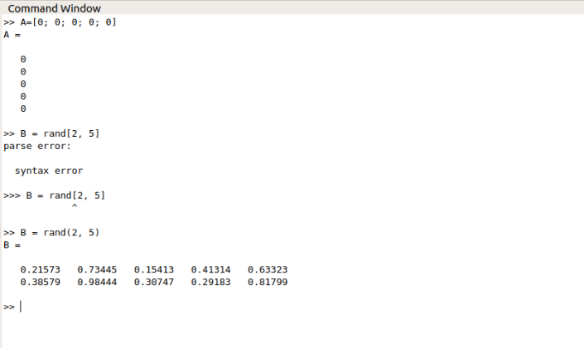

1. Multiply a column of a matrix with an element of this same matrix.

**Answer:**

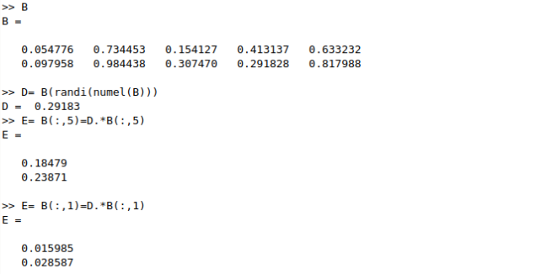

1. Create a plot of the sin function between 0 and 6π.

**ANSWER**:

x = 0:0.01:6*pi;

plot(x,sin(x)),

grid on

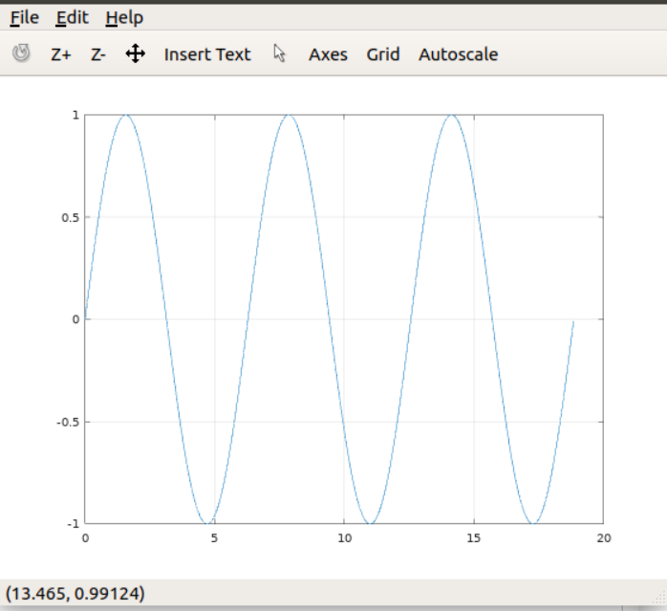

4. Simulate an amplitude modulation (AM) system with all input, carrier and output signals. Say the input signal is a cosine wave with amplitude as 2V and frequency as 1000Hz. The carrier signal is also a cosine wave with amplitude as 5V and frequency as 10KHz. The modulation degree is 0.5, and the initial phases of all cosine wave are 0. (Recall Nyquist sampling theorem to avoid distortion i.e. under sampling)

**Answer:**